Lovers production press kit
  - Student drama Producer Saleem Bradley Director Joe Beatie 2022
Lovers follows Kurtis and Ida as social pressures and unexpected events test their relationship and their hopes for a shared future. The film was produced during undergraduate screen production study at Murdoch University.
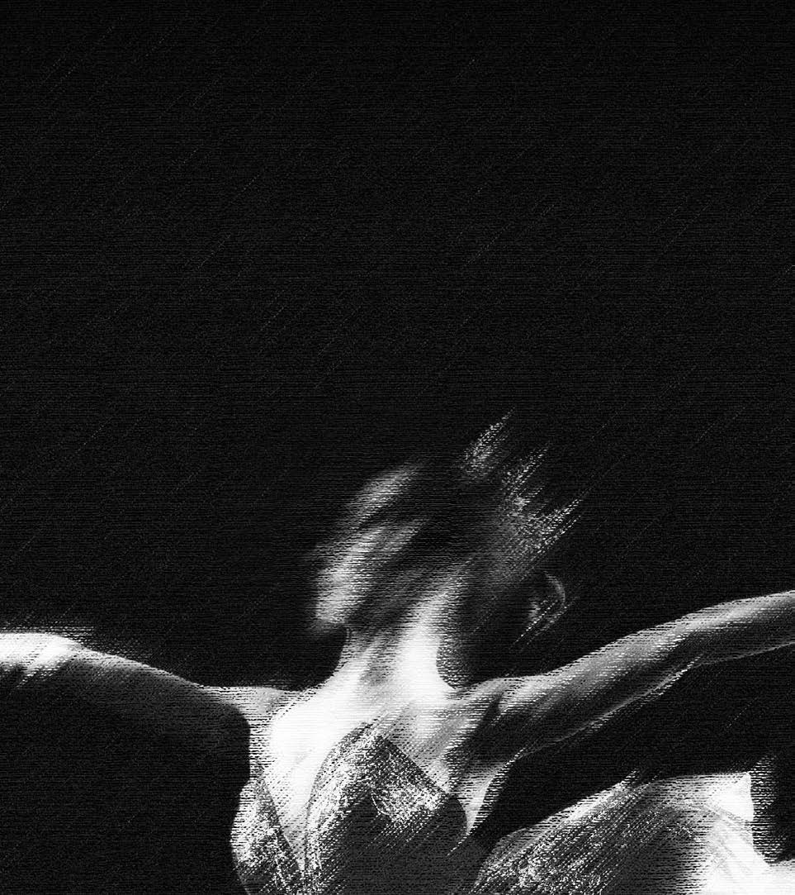
Image from the original Lovers production press kit.

Producer contribution
I produced Lovers and prepared supporting production documents covering the shooting schedule, budget planning, location safety and the proposed audience rollout. The schedule planned five days in September 2022 and coordinated scene requirements across studio, theatre and residential settings.

Personal reflection
The work I did as producer of Lovers brought me great pride and joy. This portfolio edition presents the production planning behind that work and credits the collaborators who helped bring the project together.

Cast and crew
Cast member | Role
Laurie Augimeri | Kurtis
Anya Pia | Ida
Vee McGuire | The mother
Claudia Haines-Cappeau | Ida body double
Mikayla Compton | Ballerina

Production crew
Crew member | Role
Joe Beatie | Director
Saleem Bradley | Producer
Benn Wintle | Director of photography
James Su | Production designer
Mamoun Bashir | Sound
Owen Beatie | Editor
Sasha Tasiy | First camera assistant
Cian Bye | Second camera assistant
Saiyara Arif | Production assistant
Dillon Kaskonas and Blade Schoen | First assistant directors
Zac Walker and Zoe Davis | Gaffers
Kyle X Dessent | Grip
Faye Ririnui | Key grip
Credits follow the supplied production press kit. The two first assistant director and gaffer entries have been grouped without assigning unrecorded responsibilities.

Audience and rollout plan
The proposed rollout focuses on audiences with a connection to student filmmaking, performance and dance. The original press kit identified student networks, dance communities and social media as potential routes to those audiences.

Student networks
A proposed student rollout would connect the film with relevant course communities, university media and peer networks. Suitable materials include a clear synopsis, verified credits, approved imagery and a screening link when available.

Dance communities
The film’s performance imagery offers a natural point of connection with dance audiences. Outreach would need to respect collaborators’ permissions and avoid implying any endorsement or partnership that had not been agreed.

Social media
A proposed social campaign could introduce the story, credit the cast and crew and share approved production imagery. Posts should direct viewers to a confirmed screening or release destination. The campaign would measure audience response rather than assume reach from a channel’s popularity.

Production record
The supporting documents include a shooting schedule for 19–23 September 2022, an itemised budget workbook and a location safety checklist dated 19 September 2022. Those documents are historical planning records. This press kit does not announce a new screening or release.

Professional contact
For enquiries about Saleem Bradley’s creative work, contact Bradley Creative Lab: https://www.bradleycreativelab.com/contact-us/

Sources and credits
Adapted from the original Lovers production press kit and the supplied production documents. Producer: Saleem Bradley. Director: Joe Beatie. The synopsis and audience plan have been edited for clarity and Australian English. Imagery remains attributed to the original production press kit.

